Title should be the fewest possible words that accurately describe the content of the paper (Center, Bold, 16pt)

First Author¹, Second Author², Third Author³ (10 pt)
^{1,3}Department of Information Technology, College of Computer Studies, Tarlac State Univeersity, Tarlac, Philippines
(9 pt)
²University Research Office, Tarlac State Univeersity, Tarlac, Philippines (9 pt)

Article Info |  | ABSTRACT ( 10 PT)
Article history:  NTP Date: MMM DD, YYYY  XX MONTHS  Research Duration:  REC Acceptance Date:  MMM DD, YYYY |  | A well-prepared abstract enables the reader to identify the basic content of a document quickly and accurately, to determine its relevance to their interests, and thus to decide whether to read the document in its entirety. The Abstract should be informative and completely self-explanatory, provide a clear statement of the problem, the proposed approach or solution, and point out major findings and conclusions. The Abstract should be 350 to 500 words in length. The abstract should be written in the past tense. Standard nomenclature should be used and abbreviations should be avoided. No literature should be cited. The keyword list provides the opportunity to add keywords, used by the indexing and abstracting services, in addition to those already present in the title. Judicious use of keywords may increase the ease with which interested parties can locate our article ( 9 PT).
Keywords:
First keyword
Second keyword
Third keyword
Fourth keyword
Fifth keyword
Corresponding Author:
Name of Corresponding Author,
Department or Unit,
College or Office,
University / Institution
Email: lsntl@tsu.edu.ph

- INTRODUCTION
The main text format consists of a flat left-right columns on A4 paper (quarto). The margin text from the left and top are 2.5cm, right and bottom are 2 cm. The manuscript is written in Microsoft Word, single space, Time New Roman 10pt and maximum 15 pages.

A title of article should be the fewest possible words that accurately describe the content of the paper. Omit all waste words such as "A study of ...", "Investigations of ...", "Implementation of ...”, "Observations on ...", "Effect of.....", “Analysis of …”, “Design of…” etc. Indexing and abstracting services depend on the accuracy of the title, extracting from it keywords useful in cross-referencing and computer searching. An improperly titled paper may never reach the audience for which it was intended, so be specific.
The Introduction should provide a clear background, a clear statement of the problem, the relevant literature on the subject, the proposed approach or solution, and the new value of research which it is innovation. It should be understandable to colleagues from a broad range of scientific disciplines. Organization and citation of the bibliography can be made in IEEE style [1], APA style or any other applicable citation format (Author, YYYY). The terms in foreign languages are written italic (italic). The text should be divided into sections, each with a separate heading and numbered consecutively. The section/subsection headings should be typed on a separate line, e.g., 1. Introduction. Authors are suggested to present their articles in the section structure: Introduction - the comprehensive theoretical basis and/or the Proposed Method/Algorithm - Research Method - Results and Discussion – Conclusion.

Literature review that has been done author used in the chapter "Introduction" to explain the difference of the manuscript with other papers, that it is innovative, it are used in the chapter "Research Method" to describe the step of research and used in the chapter "Results and Discussion" to support the analysis of the results. If the manuscript was written really have high originality, which proposed a new method or algorithm, the additional chapter after the "Introduction" chapter and before the "Research Method" chapter can be added to explain briefly the theory and/or the proposed method/algorithm.

- RESEARCH METHOD (10 PT)
Explaining research chronological, including research design, research procedure (in the form of algorithms, Pseudocode or other), how to test and data acquisition. The description of the course of research should be supported references, so the explanation can be accepted scientifically.
Tables and Figures are presented center, as shown in Table 1 and Figure 1 and cited in the manuscript before appeared.

Table 1. The performance of ...
Variable | Speed (rpm) | Power (kW)
x | 10 | 8.6
y | 15 | 12.4
z | 20 | 15.3

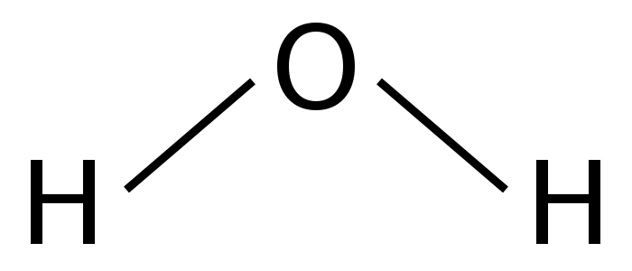

Figure 1. Chemical formula of water

- RESULTS AND DISCUSSION (10 PT)
In this section, it is explained the results of research and at the same time is given the comprehensive discussion. Results can be presented in figures, graphs, tables and others that make the reader understand
easily [11-15]. The discussion can be made in several sub-chapters.

3.1. Sub Section 1
Xx

3.2. Sub Section 2
Yy

- CONCLUSION (10 PT)
Provide a statement that what is expected, as stated in the "Introduction" chapter can ultimately result in "Results and Discussion" chapter, so there is compatibility. Moreover, it can also be added the prospect of the development of research results and application prospects of further studies into the next (based on result and discussion).

ACKNOWLEDGEMENTS (10 PT)
Xx

REFERENCES (10 PT)
The main references are international journals and proceedings. All references should be to the most pertinent and up-to-date sources. References are written in IEEE style, APA style or any other applicable citation format. References are at least 25 recently journal articles. (9 pt)

AUTHOR’S BIOGRAPHY

First author’s  Photo (3x4cm) | Xxxx (9 pt)
Second author’s photo(3x4cm) | Xxxx (9 pt)
Third author’s photo(3x4cm) | Xxxx (9 pt)

CONTRIBUTION OF AUTHORS

AUTHOR’S NAME | Current Affiliation  (University/College) | *% Contribution | Conforme  (Sign if you agree with the % distribution)
*should have a total of 100% 100%

